**[Get WordPress](https://wordpress.org/download/)**

[**Get WordPress**](https://wordpress.org/download/)

[**Get WordPress**](https://wordpress.org/download/)









[Plugins](https://wordpress.org/plugins/)

[My Favorites](https://wordpress.org/plugins/browse/favorites/) [Beta Testing](https://wordpress.org/plugins/browse/beta/) [Developers](https://wordpress.org/plugins/developers/) Search plugins



[**Get WordPress**](https://wordpress.org/download/)

[**Showcase**](https://wordpress.org/showcase/)[**Learn**](https://learn.wordpress.org/)[**Themes**](https://wordpress.org/themes/)[**Plugins**](https://wordpress.org/plugins/)[**Mobile**](https://wordpress.org/mobile/)[**Support**](https://wordpress.org/support/)[**Get Involved**](https://make.wordpress.org/)[**About**](https://wordpress.org/about/)[**Blog**](https://wordpress.org/news/)[**Hosting**](https://wordpress.org/hosting/)



[Register](https://login.wordpress.org/register?locale=en_US) [Log In](https://login.wordpress.org/?locale=en_US)

[](https://wordpress.org/about/)

Search WordPress.org

OTB WordPress Plugin – On The Bench

[Download](https://downloads.wordpress.org/plugin/computer-repair-shop.zip)

[Download](https://downloads.wordpress.org/plugin/computer-repair-shop.zip)

[Download](https://downloads.wordpress.org/plugin/computer-repair-shop.zip)

[Download](https://downloads.wordpress.org/plugin/on-the-bench.zip)

By [The Old Fashion Way](https://www.theoldfashionway.com/)

Details

Reviews

Installation

[Support](https://wordpress.org/support/plugin/computer-repair-shop/)

Development

# Description

On The Bench is a great WordPress OTB Plugin. Which can help you convert your WordPress website into a better software. Which can help you manage your services, parts, extras, jobs, technicians, and clients effectively. The On The Bench OTB WordPress plugin is the smart way to manage your customers and jobs. With ability to add extra items which you can reuse as products.

With just with one button click you can switch parts with WooCommerce products. Receipt printer is great addition for you to use roll printer easily. There is print button in invoice and repair order, so you do not need to click ctrl+p to print the invoice. Yes with featured invoice and print order styling.

Devices post type helps you define the brands you work for and their devices you accept to repair. While creating a job you can select device its IMEI or ID. So, you can have record of device you worked on with its ID.

Additionally, file attachment optional option included in case you want

Version:

Last updated: Active installations: WordPress Version: Tested up to:

PHP Version:

Tag:

# Ratings



**1.00**

**1 day ago**

**2+**

**4.0 or higher**

**5.7.2**

**7.3 or higher**

[OTB](https://wordpress.org/plugins/tags/crm/)

[**Advanced View**](https://wordpress.org/plugins/computer-repair-shop/advanced/)

[See all ](https://wordpress.org/support/plugin/computer-repair-shop/reviews/)

to add any type of file attachment in jobs page.

OTB supports multiple taxes you can use different taxes for services, extras and products as well.

Advance filters help you to filter jobs based on their status, payment status, by customer and by technician as well.

Some great features like warranty and its assessments on daily and weekly basis. The pickup and delivery option and its charges. These are service addons in your services which can benefit your customers.

Parts can have their installation charges as well as the cost of part/product.

5 stars 4

4 stars 0

3 stars 1

2 stars 0

1 star 0

Log in to submit a review.

# Support

Issues resolved in last two months:

[View support forum](https://wordpress.org/support/plugin/computer-repair-shop/)

0 out of 0

To view details please check the video below.

# A picture containing timeline Description automatically generatedDonate

advancement of this plugin?

[Donate to this plugin](https://www.webfulcreations.com/products/computer-repair-shop-crm-wordpress-plugin/)

Many more features available in this premium version. Find other details about premium version.

[Details about this Premium Version](https://www.theoldfashionway.com/products/otb-wordpress-plugin-onthebenc/)

# Screenshots

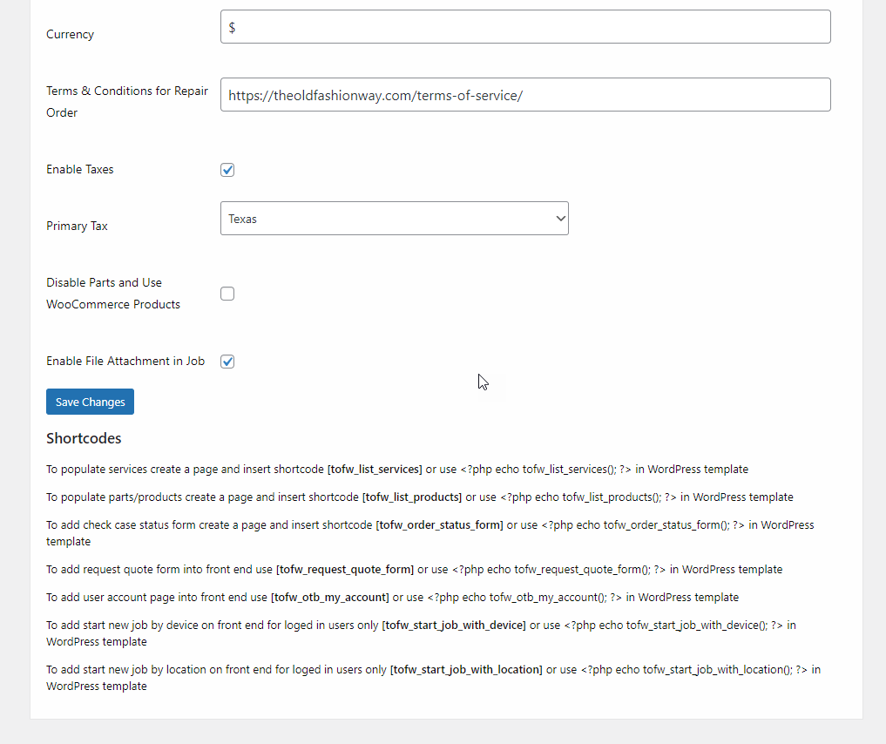

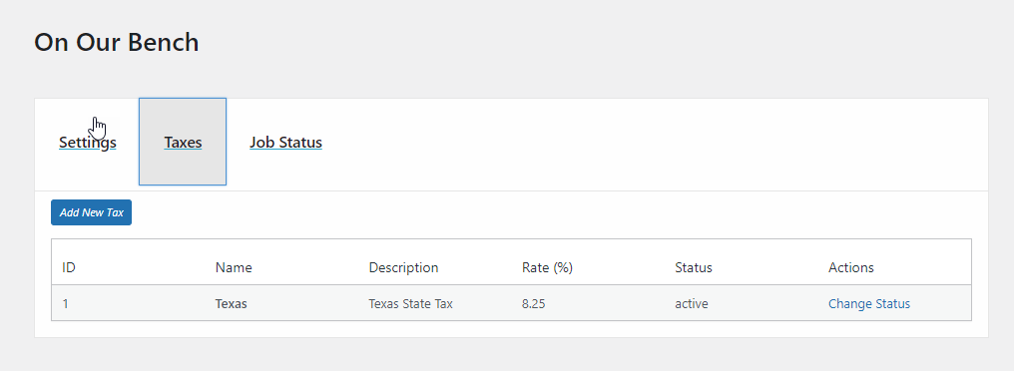

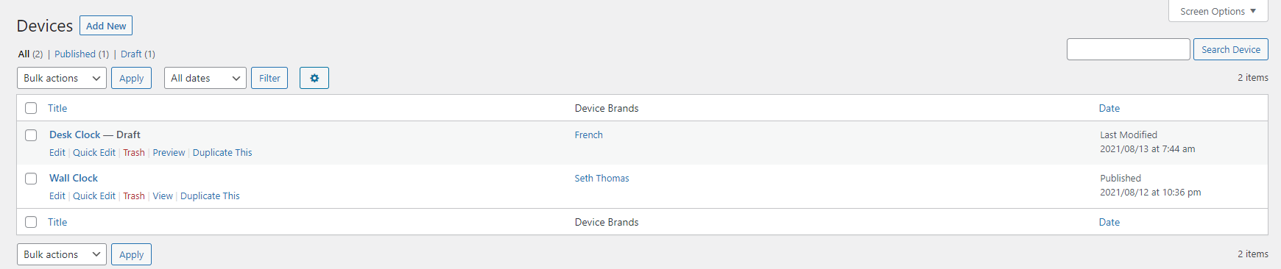

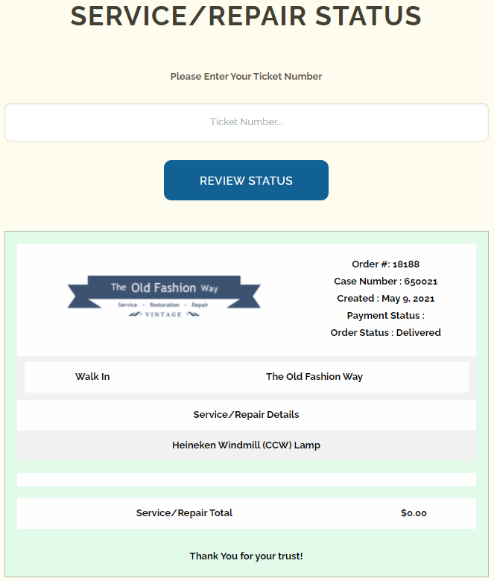

**FAQ**

**Can we translate this plugin?** 

**Can I use more than 1 taxes?** 

**Can I switch Parts with WooCommerce Products?** 

**Is there any repair order to get signed by customer?** 

**Can I add more job statuses?** 

**Is there a limit on parts/products and services?** 

# Contributors & Developers

“OTB WordPress Plugin – On The Bench” is open-source software. The following people have contributed to this plugin.

[Ronald Capodagli](https://profiles.wordpress.org/rcapodagli/)



[About](https://wordpress.org/about/) [Blog](https://wordpress.org/news/) [Hosting](https://wordpress.org/hosting/)

[Donate](https://wordpressfoundation.org/donate/)

[Support](https://wordpress.org/support/) [Developers](https://developer.wordpress.org/) [Get Involved](https://make.wordpress.org/)

[Learn](https://learn.wordpress.org/)

[Showcase](https://wordpress.org/showcase/) [Plugins](https://wordpress.org/plugins/)

[Themes](https://wordpress.org/themes/)

[WordCamp](https://central.wordcamp.org/) [WordPress.TV](https://wordpress.tv/) [BuddyPress](https://buddypress.org/)

[bbPress](https://bbpress.org/)

[WordPress.com](https://wordpress.com/?ref=wporg-footer) [Matt](https://ma.tt/)

[Privacy](https://wordpress.org/about/privacy/)

[Public Code](https://publiccode.eu/)

[@WordPress](https://twitter.com/WordPress)

[WordPress](https://www.facebook.com/WordPress/)